PRACTICAL 7

Topic: Knowledge Base (multigraph creation)

Introduction: **Characteristics of a Knowledge Base Multigraph**

1. **Entities (Nodes)**:
   * Represent real-world objects, concepts, or abstract items.
   * Examples: "Person", "City", "Movie", etc.
2. **Relationships (Edges)**:
   * Describe how two entities are connected.
   * Examples: "is_a", "lives_in", "directed_by", "acted_in".
3. **Multiple Edges**:
   * The same pair of nodes can have multiple edges with different labels.
   * Example: Between "Person" and "Movie", there could be edges like "acted_in", "directed_by", etc.
4. **Attributes**:
   * Nodes and edges may have attributes (key-value pairs) providing additional context.
   * Example: The edge "acted_in" between a person and a movie could include the attribute role: "protagonist".

Code:

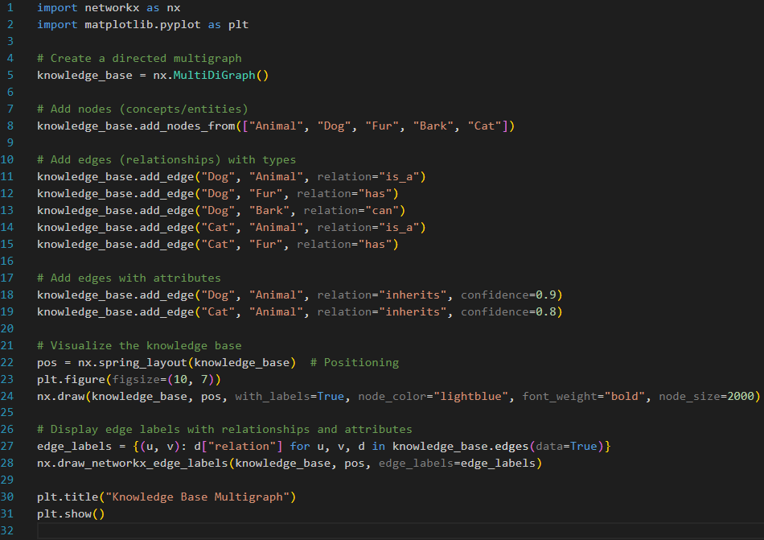

Output:

